**CMPG 223_PROJECT DOCUMENTATION**

**KRUGER NATIONAL PARK/ *ISINTO APP***

Contents

INTRODUCTION 2

PROBLEMS STATEMENT 2

PROJECT OBJECTIVES 2

CRITICAL SUCCESS FACTORS 3

SYSTEM DESIGN 3

DESCRIPTION OF DATA FLOW DIAGRAM (DFD) 4

CLASS DIAGRAM 5

ERD 6

Description of procedures and function 6

User registration 7

EVENT BOOKING 7

Guesthouse dashboard 8

HARDWARE AND SOFTWARE REQUIREMENTS 8

Software Requirements: - 9

PROJECT TESING PHRASE 9

CONCLUSION AND FUTURE WORK 10

# INTRODUCTION

Our Group has developed an application that will be used by the Kruger National Park to manage their operations. The App name is Isinto App which provides booking services in facilities such as travel tours, events, houses, holiday apartments and other accommodations to customers. Kruger national park is situated in the Republic of South Africa, it covers over 19 455 km2 and is 350 kilometers (217 miles). Any customers who need to book for travel tour, event and house or apartment need to visit their office which situated in the park for checking in as well as the availability of tour guide as well as negotiation.

Our group have approached the Kruger national Park Management and present a solution to manage their manual process of handling visitors with an automatic web-based system for managing customers who want to visit the facility and it will also help staffs to keep track of customer’s.

# PROBLEMS STATEMENT

Kruger National Pack offices were using a manual logbook system for recording travel tours, events, and room booking within the facilities. They usually faced the following challenges. The Manual logbook management tools is a complex procedure as the customers structure for every class is different. Using a manual procedure leaves many opportunities for human error, making an already complex process more tedious and challenging. In the current system, all records are on paper, which makes it difficult to get information on time and modify the information when needed. This is the reason why our group members have approached the Kruger national Park management in moving towards a web-based customer management system that streamlines the process and makes it easier and faster for reception staff to manage customers.

# PROJECT OBJECTIVES

* To mitigate human errors
* To mitigate high expenditure for procurement of manual registers
* To keep records in a softcopy format for easier retrieve and modify when needed.
* To automate the processes
* Keeping details about the users, their needs and payment detail reports
* Keep the customers connected with the facilities through receiving the confirmation information.

# CRITICAL SUCCESS FACTORS

* Simplifies Front Office Tasks since the system can provide the 'real time' status of the facilities as well as expected customers or guest.
* To mitigate human errors
* To increase efficiency and effectiveness
* To increase reliability and customer satisfaction to Kruger national Park services.

# SYSTEM DESIGN

Design is the first step in the development phase of any strategy and principles for the purpose of defining the problem statement or the process or system with sufficient detail to permit its physical realization. Once the software requirements have been analyzed and specified the software architecture need to analyze

* Design
* Coding
* implementation
* testing.

Design tasks are very important in this phase because failure in one of these tasks will affect the final product. System Design is the only way to accurately interpret the customer's requirements into the end software or system. Design is the place where quality is improved. Software development is a process where requirements exist transformed into software representation.

# DESCRIPTION OF DATA FLOW DIAGRAM (DFD)

UML design is the shortest form of “Unified Modeling Language”. The purpose of this modeling language is to visualize the design of the system.

UML for National Park System/isinto APP

Log into System

Maintain Animals

**Administrator**

# CLASS DIAGRAM

This is the most used UML diagram in the field of software engineering design. It is called as a main building block of any object-oriented solution. Usually, it illustrates the classes in a system, attributes, and operations of each class and also the relationship between each class. Below is the “CLASS DIAGRAM” of our new proposed system.

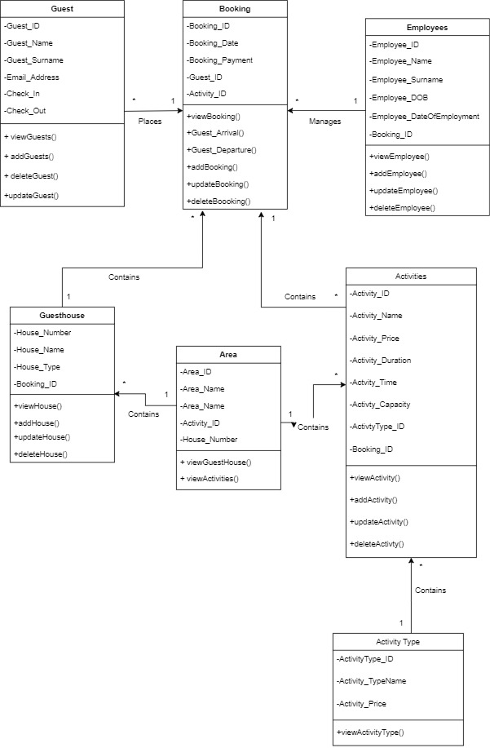

# ERD

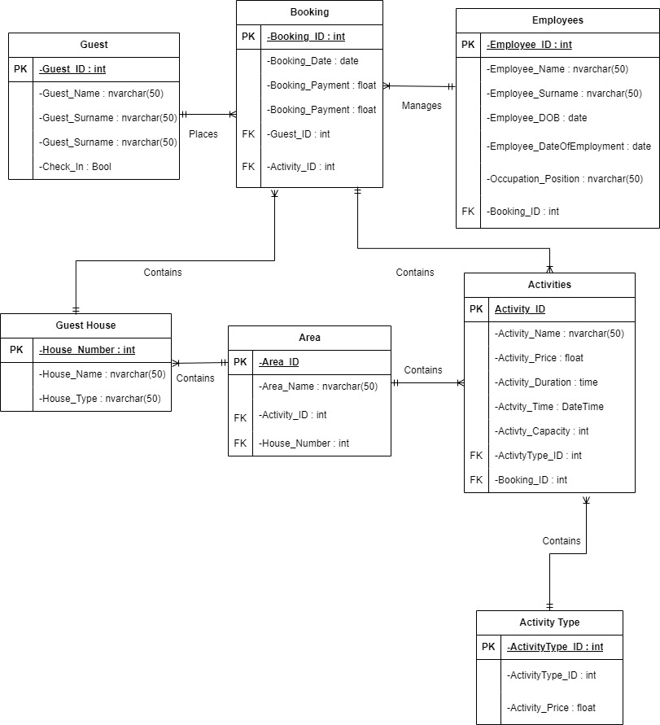

# Description of procedures and function

This project contains 3 modules namely: -

* User Registration,
* Booking Rooms,
* Submission module,

# User registration

In this module the user is required to register the usernames and passwords for user creations.

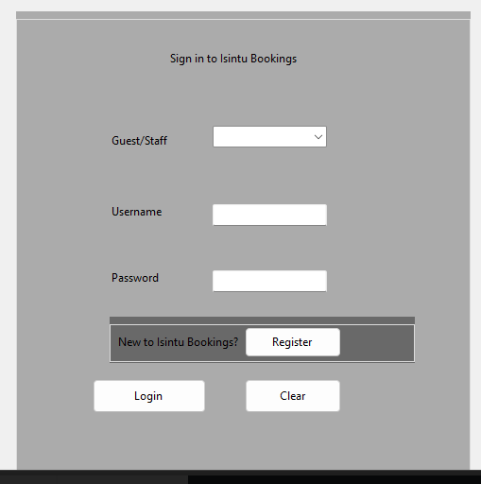

# EVENT BOOKING

A registered customer can have access to this module or dashboard.

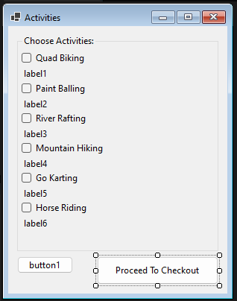

# Guesthouse dashboard

This the module where customers who want to book for accommodation will see the different accommodation facilities the Park have.

# HARDWARE AND SOFTWARE REQUIREMENTS

HARDWARE REQUIREMENTS: -

* Quad core 2GHz+ CPU.
* 6GB Ram.
* Hard disk 1 TB.
* Minimum database space: 10GB
* Processor 11th Gen Intel(R) Core (TM) i7-1165G7 @ 2.80GHz 2.80 GHz
* RAM : 16.0 GB)
* System type 64-bit operating system, x64-based processor

# Software Requirements: -

* Operating System : Windows
* Web-Technology: Azure
* Front-End: visual Studio
* Back-End: SQL Server Management Studio 19
* Web Server: Isinto-SQL Server.

# PROJECT TESING PHRASE

List of functionalities that were checked.

|  |  |
| --- | --- |
| FUNCTIONALITIES | RESULTS |
| Database design | ✓ |
| Visual studio and database Connection String |  |
| Check that website connection |  |
| USER INTERFACE |  |
| In the home page there is menu | ✓ |
| All graphic elements, texts and animations have high resolution | ✓ |
| Check that fixed menu including HELP button |  |
| USER LOGIN |  |
| Check user login page | ✓ |
| Check registration functionality |  |
| Check Login functionality |  |
| Check Forgot Password functionality |  |
| PROPER PC OPERABILITY AFTER LOGIN THE WEBSITE. |  |
| Checking the speed for website after launching |  |
|  |  |

# CONCLUSION AND FUTURE WORK

This is to conclude that the project that we undertook was worked upon with sincere effort. Most of the requirements have been fulfilled up to the mark and the requirements, except for web services requirement which can be completed within a short extension.

The project made here is just to ensure that this product could be valid in today’s real-world challenges and all forms developed have been tested before and after deployment.

Currently the system works for a limited number of administrators and customer information is limited therefore, In future we will extended customer safely by including insurance policies so that efficiency and effectiveness can be improved.